Create a React App named “bloggerapp” in with 3 components.

1. Book Details
2. Blog Details
3. Course Details

Implement this with as many ways possible of Conditional Rendering.

**Directory:**

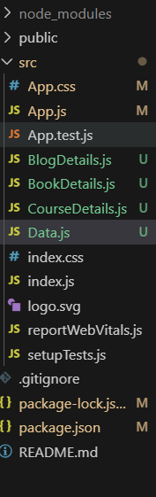

**Code for App.js:**

import React from "react";

import CourseDetails from "./CourseDetails";

import BookDetails from "./BookDetails";

import BlogDetails from "./BlogDetails";

import "./App.css"; // CSS file

function App() {

  return (

    <div className="container">

      <div className="section">

        <CourseDetails />

      </div>

      <div className="section bordered">

        <BookDetails />

      </div>

      <div className="section bordered">

        <BlogDetails />

      </div>

    </div>

  );

}

export default App;

**Code for App.css:**

.container {

  display: flex;

  justify-content: center;

  align-items: flex-start;

  margin-top: 50px;

  gap: 40px;

}

.section {

  padding: 10px 20px;

  width: 300px;

}

.bordered {

  border-left: 5px solid green;

}

**Code for BlogDetails.js:**

import React from 'react'

import { blogs } from './Data'

const BlogDetails = () => {

  return (

    <>

    {

        blogs.map((blog, index) => (

            <div key={index}>

            <h2>{blog.title}</h2>

            <p>Author: {blog.author}</p>

            <p>{blog.content}</p>

            </div>

        ))

    }

    </>

  )

}

export default BlogDetails

**Code for CourseDetails.js:**

import React from 'react'

import { courses } from './Data'

const CourseDetails = () => {

  return (

  <>

  {

    courses.map((course, index) => (

      <div key={index}>

        <h2>{course.name}</h2>

        <p>Date: {course.date}</p>

      </div>

    ))

  }

  </>

  )

}

export default CourseDetails

**Code for Data.js:**

export const courses = [

  {

    name: "Angular",

    date: "4/5/2021"

  },

  {

    name: "React",

    date: "6/3/20201"

  }

];

export const books = [

  {

    title: "Master React",

    price: 670

  },

  {

    title: "Deep Dive into Angular 11",

    price: 800

  },

  {

    title: "Mongo Essentials",

    price: 450

  }

];

export const blogs = [

  {

    title: "React Learning",

    author: "Stephen Biz",

    content: "Welcome to learning React!"

  },

  {

    title: "Installation",

    author: "Schewzdenier",

    content: "You can install React from npm."

  }

];

**Output:**

